There is no guarantee that there won't be an issue

Best thing is to ensure we have optimal planes, completed maintenance and astute crew

Slides:

Survival Rate per plane type

Operator

Type of aircraft

Location

**[YOM] - Year Of Manufacture**

FlightDate

FlightOperator

Flight Phase

Flight Type

PlaneAge

Site

Survivors

Schedule

Country

Region

Crew On Board

Crew Fatalities

Pax on Board

Pax Fatalities

Other Fatalities?

Total Fatalities

Circumstances

**PAX** – the number of passengers carried by an **airline**: • Direct **PAX** – passengers on direct flights from origin to destination.

PAX = Persons approximately.

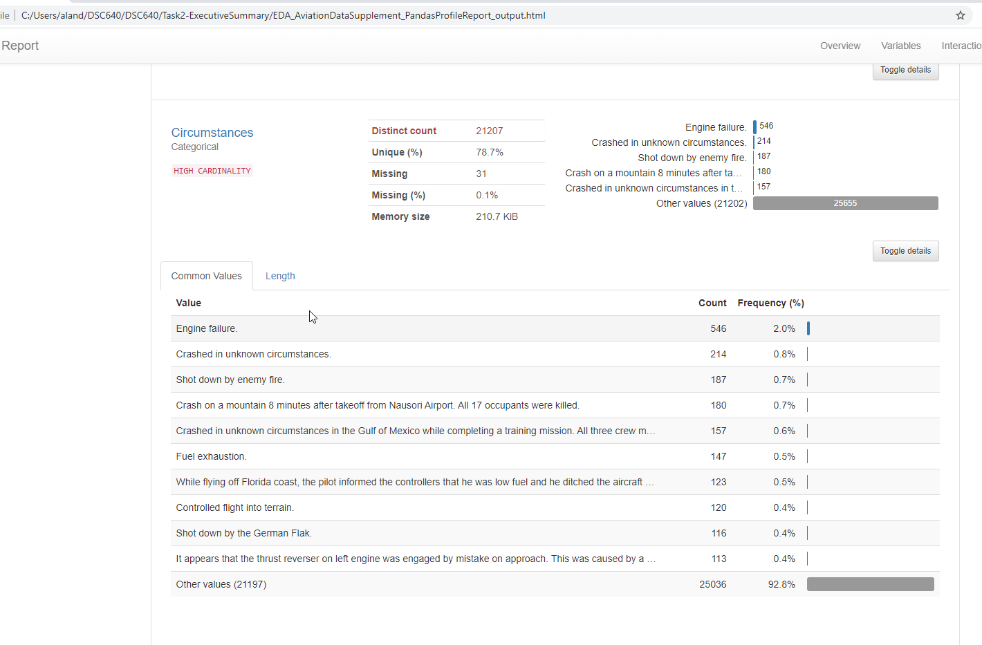

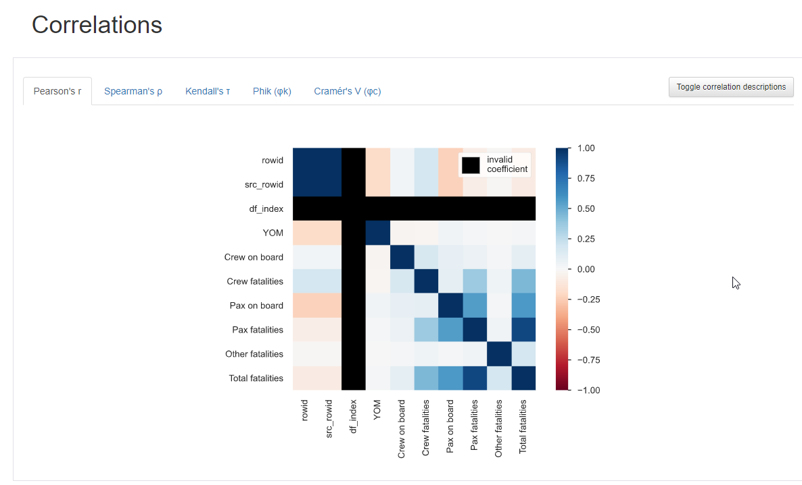

total fatalities ~ Crew fatalities & Pax fatalities

fictitious air is a prominent airline whose customer facing view is under siege.  it's customers fear that air travel is unsafe after having learned of the many air travel fatalities. here we work on a way to remediate this fear and strengthen our relationship to build a commitment to safety for our clients new and old.

For this project I wanted to share with the executive audience of Ficticious Airlines the story of their specific model of planes that have been involved in the most fatalities and the planes that have a much lower amount of fatality cases. I plan to infer the negative attributes of having such planes in their company as it can be portrayed that by continual use of these planes can cause ill faith with future customers. To accomplish this I have designed the flow of my slides so that each are purposed to highlight a concerned area supported by data fed visualizations that serve the ideas intuitively. I hope to infer the notion of the affects of such trends The action I'm inciting that the Ficticous

References

Initial Airline Dataset: https://github.com/fivethirtyeight/data/tree/master/airline-safety <https://aviation-safety.net/>

Using the following:

https://docs.google.com/spreadsheets/d/1SDp7p1y6m7N5xD5_fpOkYOrJvd68V7iy6etXy2cetb8/edit#gid =1448957446

Supplemental Data:

<http://www.baaa-acro.com/crash-archives?created=&created_1=&field_crash_region_target_id=All&field_crash_country_target_id&field_crash_registration_target_id&field_crash_aircraft_target_id&field_crash_operator_target_id&field_crash_cause_target_id=All&field_crash_zone_target_id&field_crash_site_type_target_id=All&field_crash_phase_type_target_id=All&field_crash_flight_type_target_id=All&field_crash_survivors_value=All&field_crash_city_target_id&page=1>

<http://www.baaa-acro.com/crash-archives?created=&created_1=&field_crash_region_target_id=All&field_crash_country_target_id&field_crash_registration_target_id&field_crash_aircraft_target_id&field_crash_operator_target_id&field_crash_cause_target_id=All&field_crash_zone_target_id&field_crash_site_type_target_id=All&field_crash_phase_type_target_id=All&field_crash_flight_type_target_id=All&field_crash_survivors_value=All&field_crash_city_target_id&page=2>

<http://www.baaa-acro.com/crash-archives?created=&created_1=&field_crash_region_target_id=All&field_crash_country_target_id&field_crash_registration_target_id&field_crash_aircraft_target_id&field_crash_operator_target_id&field_crash_cause_target_id=All&field_crash_zone_target_id&field_crash_site_type_target_id=All&field_crash_phase_type_target_id=All&field_crash_flight_type_target_id=All&field_crash_survivors_value=All&field_crash_city_target_id&page=1349>

http://www.baaa-acro.com/crash-archives?created=&created_1=&field_crash_region_target_id=All&field_crash_country_target_id=&field_crash_registration_target_id=&field_crash_aircraft_target_id=Airbus+A300+%2829630%29&field_crash_operator_target_id=&field_crash_cause_target_id=All&field_crash_zone_target_id=&field_crash_site_type_target_id=All&field_crash_phase_type_target_id=All&field_crash_flight_type_target_id=All&field_crash_survivors_value=All&field_crash_city_target_id=

<http://www.baaa-acro.com/crash/crash-airbus-a300b-2-203-qeshm-island-290-killed>

<http://www.baaa-acro.com/statistics/death-number-per-operator>

<http://www.baaa-acro.com/statistics/death-number-per-operator?page=1>

<http://www.baaa-acro.com/statistics/death-number-per-operator?page=110>

**http://www.baaa-acro.com/crash-archives**

https://www.nhtsa.gov/content/nhtsa-ftp/176776

521_892797_bundle_archive.zip

[https://www.kaggle.com/khsamaha/aviation-accident-database-synopses#](https://www.kaggle.com/khsamaha/aviation-accident-database-synopses)

<https://www.kaggle.com/khsamaha/aviation-accident-database-synopses>

Aviation Accident Database & Synopses

<https://www.ntsb.gov/_layouts/ntsb.aviation/index.aspx>

<https://www.ntsb.gov/_layouts/ntsb.aviation/AviationDownloadDataDictionary.aspx>

<https://rstudio-pubs-static.s3.amazonaws.com/234339_ef529d45cc564f00bed2d33d84add4d3.html>

<https://github.com/nicolasbd/aircrashes>

<https://towardsdatascience.com/data-visualisations-of-aviation-tragedies-in-the-us-since-1948-4f1d7371b799>

<https://www.kaggle.com/khsamaha/aviation-accident-database-synopses>

<https://datasciencebowl.com/data-analysis-on-aviation-accidents/>

<https://aviation-safety.net/graphics/infographics/ASN_infographic_2015.jpg>

<https://www.kaggle.com/saurograndi/airplane-crashes-since-1908>

<https://www.kaggle.com/ruslankl/airplane-crashes-data-visualization>

<https://www.kaggle.com/ruslankl/airplane-crashes-data-visualization/#data>

